Updated 11/16/17

Group 2 Use Cases & Sequence Diagrams

Create account and payment

|  |  |
| --- | --- |
| Title | Creating an Account with Paid Subscription |
| Description | Creating and paying for a student user account to be able to play the interactive game and have access to all other information. |
| Actors | Student User/Parent, Website Server, Payment Method Server |
| Triggers | Clicking “Create an Account” button |
| Main Course | 1. System prompts to create a username and password.  2. User enters desired username and password options (see AC1, EX1).  3. System prompts user to enter personal information.  4. User enters personal information (see AC2, EX1).  5. System prompts user to choose subscription type.  6. User chooses subscription type (see EX1).  7. System prompts user to choose and enter payment information.  8. User enters payment information (see AC3, EX1).  9. System brings user to user profile page. |
| Alternate Course | AC1 System already has desired username connected to another user profile.   1. Return to Main Course 2.   AC2 User inputs personal information not permitted.   1. Return to Main Course 4.   AC3 User inputs unrecognizable payment information.   1. Return to Main Course 8. |
| Exceptions | EX1 System fails to save and submit information.   1. System notifies user of error. 2. Returns to Main Course 1. |
| Pre- Conditions | User has access website domain. System must be fully configured. |
| Post- Conditions | The user now has a profile with their information linked to it. |

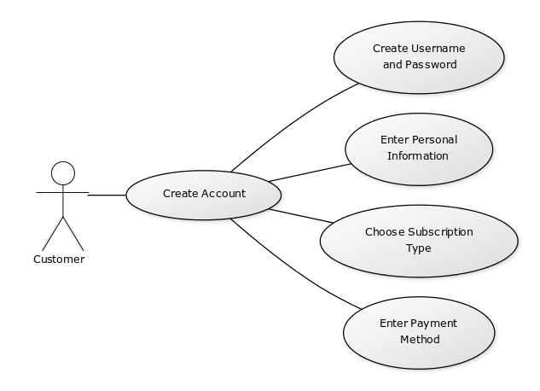

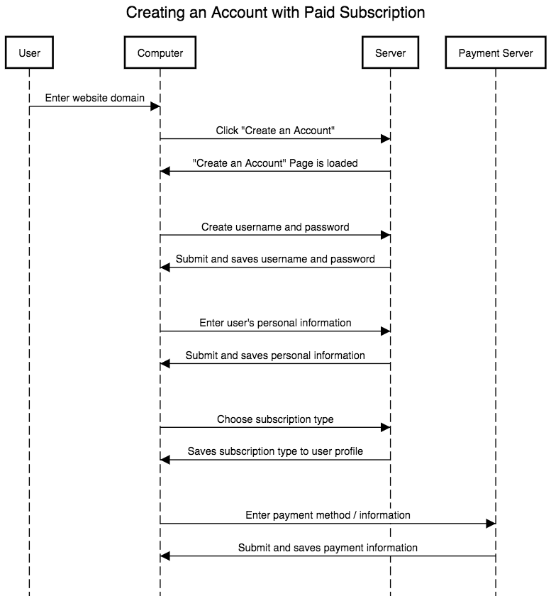

Zipcode/Location search - Gabe

|  |  |
| --- | --- |
| Title | Zipcode/Location search |
| Description | Users wants to share own location ,view trainers location and navigate to |
| Actors | Students , trainer's, Site Admin |
| Triggers | Students wants to find closes training professional |
| Main Course | 1. Students turns on his/her location  2. The student request training professional  2. Registered training professional turn on their location  3. Student searches website’ database for suitable trainer.  4. Student sends request for training.  5. Professional approves request  6.Student receives approval request  6. Navigation from current location to destination will open in google maps. |
| Alternative Course | AC1 Professional rejects training request.   1. Professional responds to student with reason with rejection. 2. Student must view other listing submit request somewhere else. (See AC2) |
| Exceptions | EX1 Request is not sent due to system error.   1. Site administrator attempts to publish again at a later time. |
| Pre-conditions |  |
| post-conditions |  |

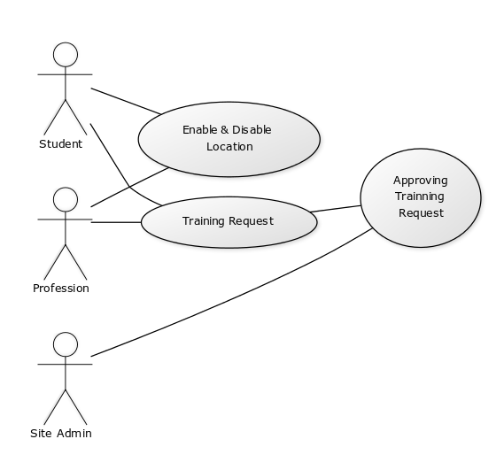

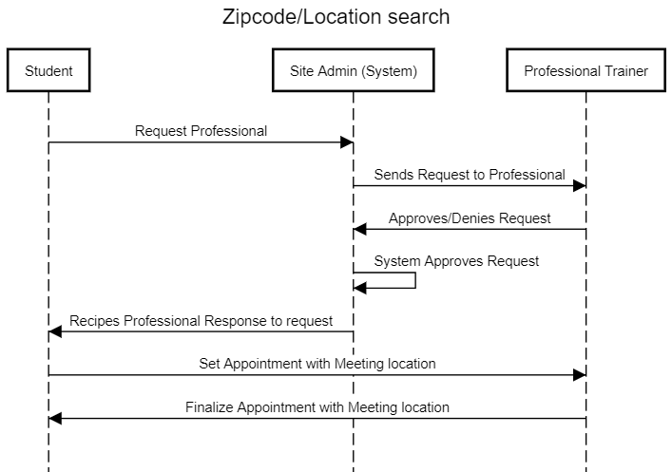

Professional adding services - Kiersten

|  |  |
| --- | --- |
| Title | Professionals Adding Service Listings to Website |
| Description | A health, fitness or nutrition expert wants to list their services on the website for parents, students and school officials to view. |
| Actors | Professional, Site administrator, Parents, Students, School officials |
| Triggers | Professional wants to list a service. |
| Main Course | 1. Professional creates draft of listing of their service to be published. 2. Professional submits listing to site administrator. 3. Site administrator receives and reviews listing. 4. Site administrator approves listing. (See AC1) 5. Site administrator publishes listing. (EX1) |
| Alternate Course | AC1 Site administrator rejects listing.   1. Site administrator responds to professional with reason with rejection. 2. Professional can revise listing and resubmit. (See AC2)   AC2 Professional does not revise listing and does not resubmit. |
| Exceptions | EX1 Listing is not published due to system error.   1. Site administrator attempts to publish again at a later time. |
| Pre- Conditions | Professionals exist with services they want to list. |
| Post- Conditions | A professional’s listing is posted to the site for parents, students and school officials to view. |

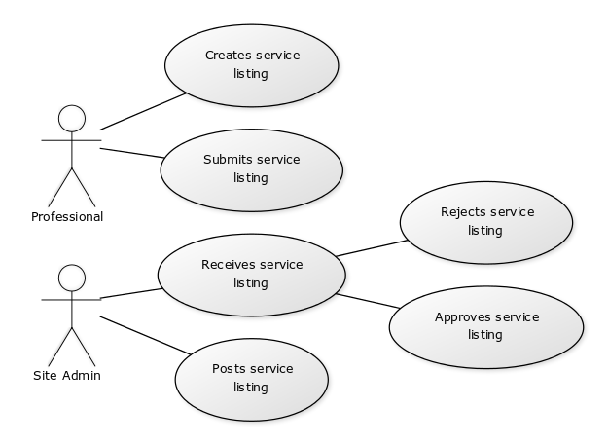

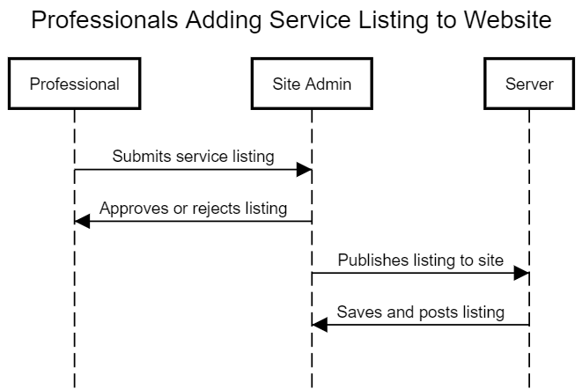

Users browsing services - Gabe

|  |  |
| --- | --- |
| Title | Users browsing services |
| Description | Users will be able to log into the website and view services provides such as set appointment, view available lessons, interact with others using social media |
| Actions | Students will access website to use features |
| Triggers | Users Accesses website |
| Main Course | 1. Student will login into websites 2. Students will have the option to :    1. View available lessons    2. Set an appointment to meet with an official    3. Interact with social media |
| Alternate Course | AC1 User is unable to login  1.Return to Main course 1 |
| Exceptions | EX1 No lessons are displayed   1. User can wait until the Site Admn make necessary fixes |
| Pre-conditions | User has access website domain. System must be fully configured |
| Post- conditions | The setting user profile has successfully been changed. |

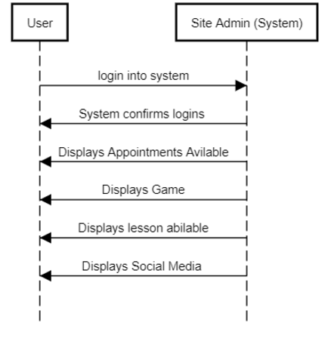

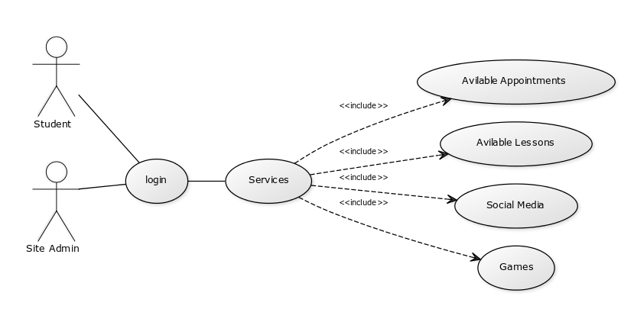

Social Media interaction - Faraz

|  |  |
| --- | --- |
| Title | Social Media Interaction |
| Description | User should be able to post to different social media services from within the site itself. |
| Actors | Student User, Parent |
| Triggers | Tweet button, Facebook post button, any other applicable social media |
| Main Course | 1. Student wants to share their thoughts on the service on Twitter. 2. Student wants to share a game achievement on Twitter. 3. Students should be able to share their stats to compare with their friends. 4. Parent wants to leave a review of the site to Facebook. |
| Alternate Course | 1. If the child is under 18 or so, the social media features are automatically disabled. |
| Exceptions | 1. Parent takes over and disables social media features for their child through their own account. |
| Pre- Conditions | 1. A script that checks for anything explicit and automatically flags profanity and other inappropriate content. 2. Student must already be logged into these social media services to be able to post/read content. 3. Users should be able to browse these respected feeds through channels that only display content about the site (hashtags, etc.). |
| Post- Conditions | Someone must monitor the social media feeds once they’re set up. (For moderating controversial topics that the script won’t catch, such as political discussion) |

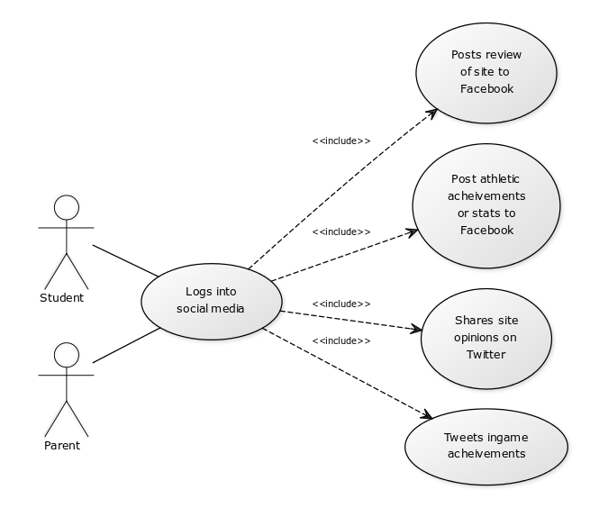

Parent accessing child’s profile/Coach’s accessing player’s profile - Faraz

|  |  |
| --- | --- |
| Title | Accessing child’s profiles |
| Description | Users such as parents and coaches should be able to view the kid’s profile without hassle. |
| Actors | Students, Parents, Coaches |
| Triggers | Edit account preferences button, view athlete/game stats button |
| Main Course | 1. Parents access profile to edit and fix health stats. 2. Parents should be able to tweak content settings for their kid. 3. Coaches should be able to view athletic stats that the child has on their profile. 4. Coaches should be able to change the athlete’s positions and teams when need be. |
| Alternate Course | 1. Parent has no access to the account and a sign-up link is sent to the kid’s inbox to approve access. |
| Exceptions | 1. Child has special permissions so that coaches can’t view stats. |
| Pre- Conditions | 1. Parents must set up account access prior to child using the services to make sure they only see approved content. |
| Post- Conditions | The settings are changed universally for the student’s account on the site. |

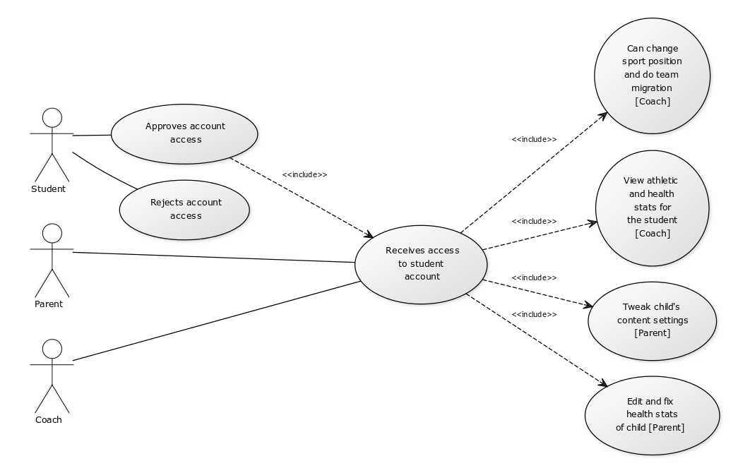

Game interaction

|  |  |
| --- | --- |
| Title | Playing the Interactive Game |
| Description | Using your account to play the Interactive Game on the Site |
| Actors | Student/User, Game system, web server |
| Triggers | Clicking on the game link |
| Main Course | 1. System prompts user to select a level to play  2. User selects a level, you must complete level 1 to move to level  3. System shows level selected by user  4. User plays level  5. Once user completes level, he continues to the next level  6. Once user selects quit, website server prompts to save progress  7. When user saves, web server saves progress for that user |
| Alternate Course | AC1 User isn’t logged in to site and tries to play the game   1. Website server rejects access to the game 2. Prompts user to sign in, or create an account   AC2 User doesn’t save game  1. Website server doesn’t update progress for that user |
| Exceptions | EX1 User tries to select level that they do not have access to  1. System looks at users progress and rejects access to the level  2. System prompts user that they do not have access to that level  3. User plays level that they have access to instead |
| Pre- Conditions | User is accessing website domain, having an account on the site |
| Post- Conditions | The user now has played the game and saved their progress |

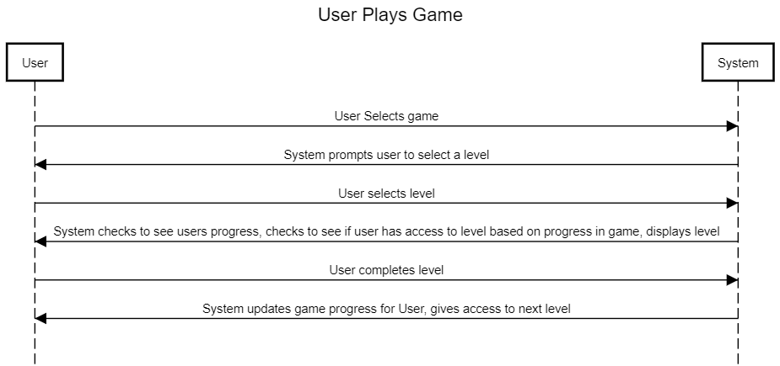

Sponsor chosen and added to the site

|  |  |
| --- | --- |
| Title | Sponsor chosen and added to the site |
| Description | The school committee selects sponsors, and the sponsor’s information is added to the website. |
| Actors | School committee, site administrator, company/organization |
| Triggers | Company/organization wants to sponsor the website. |
| Main Course | 1. A company/organization submits an application to the school committee to be a sponsor. 2. The school committee selects the sponsors for the site and sends their information to the site administrator. 3. The school committee sends a link to the page on the site where the company/organization can donate. 4. The site administrator receives and reviews the list of sponsors. 5. The site administrator publishes the sponsors (EX1). |
| Alternate Course |  |
| Exceptions | EX1 Sponsor is not published due to system error.   1. Site administrator attempts to publish again at a later time. |
| Pre- Conditions | A company or organization wants to sponsor the site. |
| Post- Conditions | The list of sponsors is added to the website. |

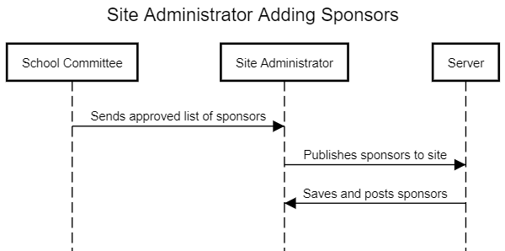

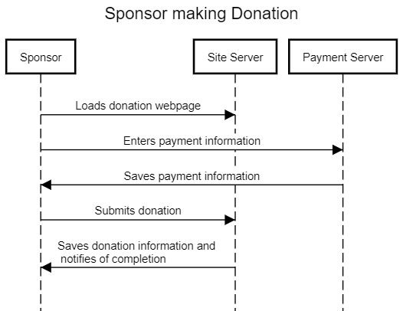

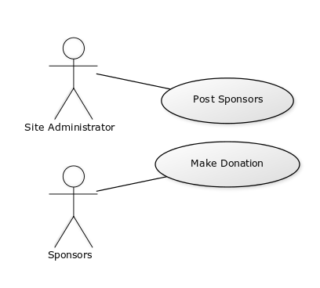

<http://sequencediagram.org/>

<https://yuml.me/diagram/usecase/samples>